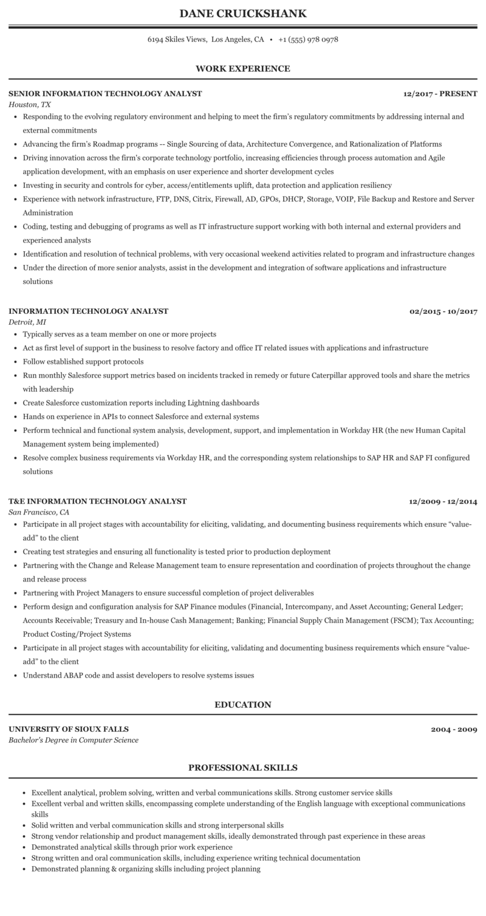
DANE CRUICKSHANK
6194 Skiles Views, Los Angeles, CA
.
+1 (555) 978 0978
WORK EXPERIENCE
SENIOR INFORMATION TECHNOLOGY ANALYST
Houston, TX
12/2017 - PRESENT
• Responding to the evolving regulatory environment and helping to meet the firm's regulatory commitments by addressing internal and external commitments
⚫ Advancing the firm's Roadmap programs -- Single Sourcing of data, Architecture Convergence, and Rationalization of Platforms
• Driving innovation across the firm's corporate technology portfolio, increasing efficiencies through process automation and Agile application development, with an emphasis on user experience and shorter development cycles
⚫ Investing in security and controls for cyber, access/entitlements uplift, data protection and application resiliency
• Experience with network infrastructure, FTP, DNS, Citrix, Firewall, AD, GPOS, DHCP, Storage, VOIP, File Backup and Restore and Server Administration
⚫ Coding, testing and debugging of programs as well as IT infrastructure support working with both internal and external providers and experienced analysts
• Identification and resolution of technical problems, with very occasional weekend activities related to program and infrastructure changes ⚫ Under the direction of more senior analysts, assist in the development and integration of software applications and infrastructure solutions
INFORMATION TECHNOLOGY ANALYST
Detroit, MI
⚫ Typically serves as a team member on one or more projects
02/2015-10/2017
• Act as first level of support in the business to resolve factory and office IT related issues with applications and infrastructure
• Follow established support protocols
⚫ Run monthly Salesforce support metrics based on incidents tracked in remedy or future Caterpillar approved tools and share the metrics with leadership
• Create Salesforce customization reports including Lightning dashboards
⚫ Hands on experience in APIs to connect Salesforce and external systems
• Perform technical and functional system analysis, development, support, and implementation in Workday HR (the new Human Capital Management system being implemented)
⚫ Resolve complex business requirements via Workday HR, and the corresponding system relationships to SAP HR and SAP FI configured solutions
T&E INFORMATION TECHNOLOGY ANALYST
San Francisco, CA
12/2009 - 12/2014
• Participate in all project stages with accountability for eliciting, validating, and documenting business requirements which ensure "value- add" to the client
• Creating test strategies and ensuring all functionality is tested prior to production deployment
• Partnering with the Change and Release Management team to ensure representation and coordination of projects throughout the change and release process
• Partnering with Project Managers to ensure successful completion of project deliverables
• Perform design and configuration analysis for SAP Finance modules (Financial, Intercompany, and Asset Accounting; General Ledger;
Accounts Receivable; Treasury and In-house Cash Management; Banking; Financial Supply Chain Management (FSCM); Tax Accounting; Product Costing/Project Systems
• Participate in all project stages with accountability for eliciting, validating and documenting business requirements which ensure "value- add" to the client
• Understand ABAP code and assist developers to resolve systems issues
UNIVERSITY OF SIOUX FALLS
Bachelor's Degree in Computer Science
EDUCATION
PROFESSIONAL SKILLS
2004-2009
• Excellent analytical, problem solving, written and verbal communications skills. Strong customer service skills
⚫ Excellent verbal and written skills, encompassing complete understanding of the English language with exceptional communications skills
• Solid written and verbal communication skills and strong interpersonal skills
• Strong vendor relationship and product management skills, ideally demonstrated through past experience in these areas
• Demonstrated analytical skills through prior work experience
• Strong written and oral communication skills, including experience writing technical documentation
• Demonstrated planning & organizing skills including project planning

